Basic Java Codes
1)
class Main {
public static void main(String[] args) {
System.out.println("Hello Sparsh");
}
}
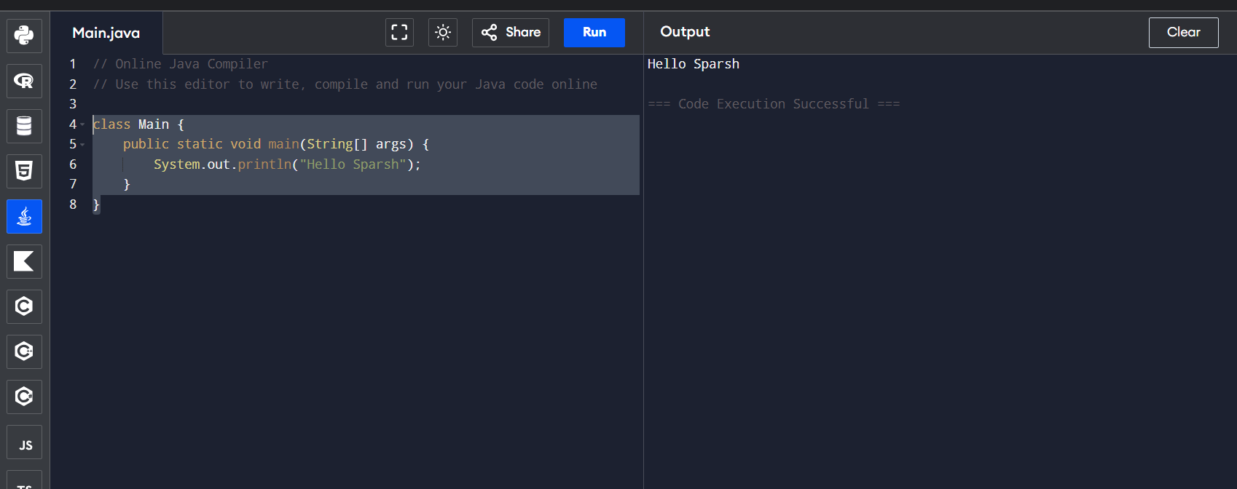

2)
class Main {
public static void main(String[] args) {
System.out.println("Sparsh\tAzad\tHarsh\tHarsh\tAditya\tKaustubh");
}
}
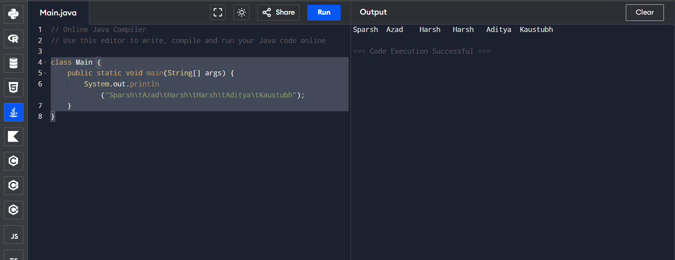

3)
class Main {
public static void main(String[] args) {
System.out.println("Sparsh\nAzad\nHarsh\nHarsh\nAditya\nKaustubh");
}
}
